Jawaban dokumen teknis

1. Entity Relationship Diagram (ERD)

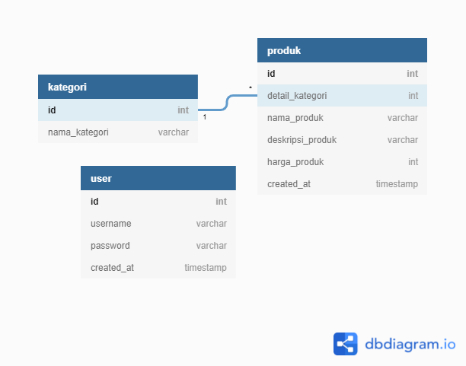

1. Data Manipulation Language (DML)
2. Select [nama kolom] from [nama tabel]
3. Update [nama tabel] set [nama kolom = nilai] where [kondisi berdasarkan apa]
4. Insert into [nama tabel] [nama kolom] values [valuenya]
5. Delete from [nama tabel] where [kondisi berdasarkan apa]
6. Activity Diagrams

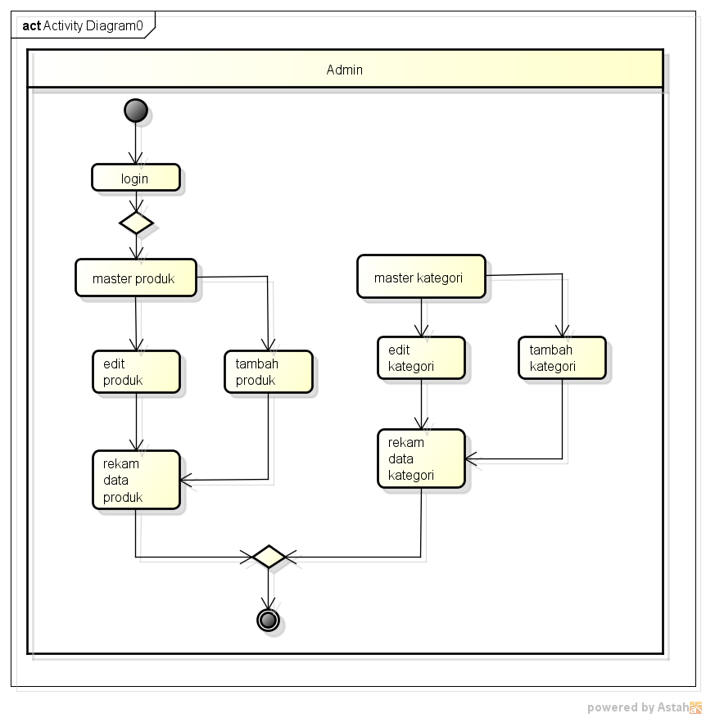

1. Use Case Diagram

